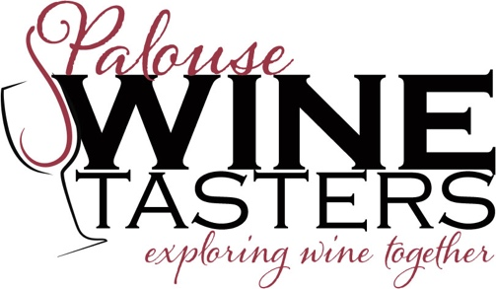
The Event:
What: South African Wines
Where: St Mark's Episcopal Church, 111 S. Jefferson, Moscow
When: 7:00pm, Saturday, April 4, 2009
Cost: $21 for members, $26 for guests

Please join us in exploring wines from South Africa. South Africa has a wine history dating back to 1659, but only recently have their wines been accessible to the world market. First, we will taste 4 white wines from various origins. In the second flight we will explore Pinotage wines. Pinotage, a cross between Pinot Noir and Cinsault, is South Africa’s own grape variety. The last flight will include 3 Cabernet blends from the Stellenbosch region. Bread and cheese will accompany the tasting. Seating is limited as this is a one bottle tasting so get your reservations in early (limit of 24 people). Remember a reservation is made by sending in your checks to the PO Box. Thanks.

The wines:
Opener:
2007 Simonsig Chenin Blanc Stellenbosch

1st flight
2007 Neil Ellis "Sincerely" Sauvignon Blanc
2006 Ataraxia Sauvignon Blanc Western Cape
2006 Sequillo Rhone White Blend

2nd flight
2007 Southern Right (Hamilton Russell) Pinotage Walker Bay
2006 Wildekrans Pinotage Walker Bay
2006 Goats do Roam Red

3rd flight
2004 Meerlust "Rubicon" Red Bordeaux Blend Stellenbosch
2007 The Left Bank (Neil Ellis) Cabernet-Shiraz-Merlot Stellenbosch
2005 Stark-Conde Cabernet Sauvignon Stellenbosch

----------------COUPON-----------------------------------------------------
Yes, we are coming to the South African Wines event on Saturday, April 4, 2009 at 7:00 PM . I have enclosed a check for $____________ for _______ persons ($21 for members, $26 for guests). Please make checks payable to Palouse Chapter Enological Society. The event will be held at St Mark's Episcopal Church, 111 S. Jefferson, Moscow, ID (St. Mark's does not sponsor this event).

I(We) would also like to become a member (or renew) of the Palouse Chapter-Pacific Northwest Enology Society membership for another year (September 1, 2008-August 31, 2009). I(We) have enclosed ____________ for _____ persons ($18 for one and $31 for two).

Name ___________________________________________________________________

Street____________________________________________________________________

City _____________________State ____________________Zip ___________

Phone: Daytime ___________________________Nighttime __________________

email address_________________________________________________________
-----------------COUPON-----------------------------------------------------

Send your coupon/reservation to:
Palouse Chapter
PO Box 8274
Moscow, ID 83843
url: www.palousewine.org

